VISVESVARAYA TECHNOLOGICAL UNIVERSITY
BELAGAVI-590018, KARNATAKA

5th Semester Mini Project Report (BEE586)
on

AUTOMATED BIOMEDICAL WASTE MANAGEMENT

USING ARDUINO AND UV STERILIZATION
Submitted by
VINAY C S 4UB23EI059
VIVEKANAND R K 4UB23EI062
Y U SNEHA 4UB23EI061
BHAVANA T S 4UB23EI062

Smt. Rachna H B Dr. Mallikarjun S. Holi
Assistant Professor (Ad-hoc) Professor & Chairman

Dr. D. P. Nagarajappa
Principal


Dept. of Electronics and Instrumentation Engineering
University B.D.T. College of Engineering
(A Constituent College of VTU, Belagavi)
Davangere-577004, Karnataka

2025-26
UNIVERSITY B.D.T. COLLEGE OF ENGINEERING
DAVANGERE-577004, KARNATAKA

(A Constituent College of VTU, Belagavi)

DEPARTMENT OF ELECTRONICS AND INSTRUMENTATION ENGINEERING

CERTIFICATE

This is to certify that the Mini Project Work entitled “AUTOMATED BIOMEDIACL WASTE MANAGEMENT USING ARDIUNO AND UV STERILIZATION” is carried out Mr. Vinay C S(4UB23EI058), Mr. Vivekanand R K(4UB23EI059), Ms. Y U Sneha(4UB23EI061) and Ms. Bhavana T S(4UB23EI062), by bonafide students of UNIVERSITY B.D.T. COLLEGE OF ENGINEERING, DAVANGERE, in partial fulfillment for the 3rd Year Bachelor of Engineering degree in ELECTRONICS & INSTRUMENTATION ENGINEERING of Visvesvaraya Technological University, Belagavi, during the year 2025-26. It is certified that all corrections and suggestions indicated for internal assessment have been incorporated in the report. The project report has been approved as it satisfies the academic requirements in a respect to Mini Project Work prescribed for the 3rd Year Bachelor of Engineering degree.

Smt. Rachna H B Dr. Mallikarjun S. Holi
Assistant Professor(Ad-hoc) Professor & Chairman

------------------------------------------------------------------------------------------------
INTERNAL VIVA

Name of the Examiner Signature with Date

------------------------------------------ ----------------------------

------------------------------------------ ----------------------------

ACKNOWLEDGEMENT

In spite the sense of achievement experienced with completion of this project presentation,
it is never complete without expressing gratitude to those who made it possible and whose constant
encouragement has marked our efforts with success.

We would specially thank our project guide, SMT. RACHNA H B, Assistant Professor(ad-hoc),
Department of Electronics and Instrumentation Engineering for the knowledgeable direction, support,
and insightful advice at each stage.

Furthermore, we would like to convey our sincere gratitude to Dr. Mallikarjun S. Holi, Chairman
of Department of Electronics and Instrumentation Engineering for inspiring and motivating us to
complete the project in the department.

We would also like to thank all the Teaching and Non-Teaching staff members who have supported
directly or indirectly for completion of this work.

We are delighted to recognize and offer our genuine appreciation to our friends for their unwavering
support, motivation and also to our well - wishers for their assistance and collaboration.

Names of the Project Associates
VINAY C S
VIVEKANAND R K
Y U SNEHA
BHAVANA T S

TABLE OF CONTENTS

Contents Page Number
Abstract 05
- Introduction 06
- Literature Survey 07
- Problem identification, Motivation and Objectives 09
- Materials and Methodology 10
  - Block Diagram 10
  - Working of the Project 11
  - Components used in proposed project 13
- Results and Discussion 20
- Advantages, Limitations, Applications and Conclusion 22
Cost Estimation 24
References 25
Appendix-1: Program Code 27
- Project Batch Students Details 35

ABSTRACT

Biomedical waste management is a critical issue in healthcare facilities due to the potential risks of infection, contamination, and environmental pollution. The proposed system, Automatic Biomedical Waste Segregation and UV Light Sterilization, aims to automate the process of classifying and disinfecting biomedical waste efficiently and safely. The system utilizes sensors such as ultrasonic sensor and moisture sensors to identify and segregate waste into categories like plastic, metallic, and organic. Before the waste is disposed it undergoes UV light sterilization, ensuring that harmful microorganisms are eliminated prior to final handling or disposal. A microcontroller (such as Arduino) acts as the central control unit, processing sensor data and operating mechanical components like servo motors or conveyor belts for waste movement. This automated approach minimizes human contact with hazardous materials, ensures accurate segregation, and promotes eco-friendly waste management in hospitals and laboratories. The combination of automation and pre-disposal sterilization significantly enhances both safety and efficiency in biomedical waste handling.

CHAPTER 1

INTRODUCTION

The rapid growth of healthcare facilities, diagnostic centers, and biomedical laboratories has led to an exponential increase in biomedical waste generation. Biomedical waste refers to any waste that is generated during the diagnosis, treatment, or immunization of human beings or animals, or during related research activities. This includes items such as used syringes, bandages, gloves, pathological waste, and other materials contaminated with bodily fluids. If not handled and disposed of properly, such waste poses significant risks to human health, the environment, and public safety. Traditional biomedical waste management methods rely heavily on manual handling, which increases the likelihood of exposure to infectious materials and human error during segregation and disposal. In many developing countries, improper segregation, inadequate sterilization, and unsafe disposal methods have contributed to the spread of infectious diseases such as hepatitis, HIV, and other microbial infections. To address these challenges, there is a need for an automated, contactless, and intelligent waste management system that can ensure proper handling and sterilization while minimizing human intervention. The proposed Automated Biomedical Waste Management System using Arduino and UV Sterilization aims to provide an efficient, safe, and cost-effective solution. The system employs an Arduino microcontroller as the central processing unit, interfaced with various sensors to identify, classify, and segregate biomedical waste automatically. When waste is detected, the system categorizes it according to predefined parameters and directs it to the appropriate bin using servo motors or actuators. This automation not only ensures proper segregation but also significantly reduces the risk of human contact with contaminated materials. In addition to segregation, the system integrates UV-sterilization technology to disinfect the collected waste. Ultraviolet (UV) light, particularly in the UV range (200–280 nm), has been proven effective in inactivating bacteria, viruses, and other microorganisms by damaging their DNA and RNA. By incorporating UV sterilization within each bin, the system ensures that waste is periodically disinfected, thereby reducing the microbial load and preventing secondary contamination.

CHAPTER 2

LITERATURE SURVEY

1. Harinipriya S. et al.[1], proposed “Portable Health Waste Disinfector and Disposer,” a system that efficiently treats medical waste to prevent pollution and disease. It includes automated segregation, a shredder, and a sterilization unit using UV light, chlorination, and heat, ensuring safe and eco-friendly waste management.

2. Slamet Wardoyo et al.[2], proposed “Effectiveness of a Ultraviolet-Equipped Waste Box in Reducing Bacterial Contamination in Laboratory Waste.” The study introduces a UV-equipped waste box that inhibits the growth of Staphylococcus aureus, offering a safer and more efficient alternative to traditional waste management methods.

3. Yoon-Soo Park et al.[3], proposed “A Study of the Effect of Testing for Diversification of Healthcare Waste Sterilization and Crushing Facilities.” The study found steam and microwave sterilization to be highly effective and suggested diversifying facilities to improve healthcare waste treatment efficiency.

4. Amy Roselin C. et al.[4], proposed “A UV and Arduino-based system that automates sterilization and monitoring for safer biomedical waste management in hospitals”. The device integrates sensors and a needle breaker to minimize contamination and enhance the safety and efficiency of hazardous waste handling.

5. Azwati Azmin et al.[5], proposed “Ultraviolet Disinfection for Bio-Contaminated Surfaces with Image-Based Navigation”. The paper presents a low-cost UV sanitization robot using Arduino Uno, Blynk app, and wireless sensors for obstacle and human detection, effectively reducing COVID-19 transmission risks.

6. Calin Ciugudeanu et al.[6],proposed “SteriLightVent - a hybrid UV-C decontamination system for simultaneous air and surface sterilization”. It uses dual UVC technologies with automated sensors for human detection, providing safe and efficient disinfection in hospitals and public spaces.

7. Vivek Mandra et al.[7], proposed a “UV Sterilizing Dustbin to promote safer and more hygienic waste management during the COVID-19 pandemic”. The automated bin uses UV light to neutralize viruses and bacteria at the source, reducing infection risks and ensuring safer waste handling.

8. Alireza Mohtasebi et al.[8], proposed “Effective Methods for the Decontamination of Healthcare Waste: Ozone and UV-C Radiation Process”. The study emphasizes sustainable alternatives like ozone gas and UV-C radiation for disinfecting healthcare waste, highlighting their combined potential to enhance sterilization efficiency.

9. Mohamed A. Aboamer et al.[9], proposed “A Comparative Study of Mechanical Behavior of ABS Material Based on UVC Sterilization for Medical Usage”. The paper investigates the impact of UVC sterilization on the mechanical properties of ABS polymer materials used in medical devices, confirming its strong antimicrobial effectiveness.

10. Harriet Runcie[10], proposed “Sort Your Waste! An Audit on the Use of Clinical Waste Bins and Its Implications”. The study revealed poor segregation practices in NHS hospitals, with 59% of non-clinical waste found in clinical bins, stressing the need for staff education and better waste management strategic.

11. Dr. Pooja Raundale et al.[11], proposed “IoT Based Biomedical Waste Classification, Quantification and Management”, an IoT-based system using smart bins, RFID tags, and sensors for automatic waste segregation and monitoring. It reduces human error, fraud, and ensures real-time eco-friendly waste handling.

12. I Putu Dharma Yudha et al.[12], proposed “Developing Sustainable Solid Medical Waste Management Based on ERP”, which uses the Odoo ERP system to integrate and automate hospital waste sorting, processing, and reporting, ensuring sustainable and efficient management.

13. Inayatulloh and Felicia Evan[13], proposed “Optimizing Waste Management Operational Performance through Blockchain”, introducing blockchain for transparency and secure tracking of waste from source to disposal using smart contracts and peer validation.

14. Yasaman Vaziri and Ali Hassan Sodhro[14], proposed “Energy-Aware Smart Routing for Biomedical Waste Management,” applying 6G edge intelligence and algorithms like ACO and Dijkstra’s to optimize waste transport routes, saving energy and improving safety.

2.1 IMPORTANT FINDINGS FROM LITERATURE:

Ultraviolet (UV) light at 254 nm is highly effective in killing bacteria and viruses by damaging their DNA and RNA, making it a reliable method for disinfection in healthcare and environmental applications. Arduino-based automation enhances safety and efficiency by reducing human exposure, improving consistency, and enabling autonomous control. Integrating features like Moisture sensor and IR sensors, or combining sterilization with waste management, increases functionality and promotes hygiene. In hospitals, UV models have achieved over 80% reduction in microbial contamination, proving effective in infection control. Moreover, portable and energy-efficient designs support sustainability, with future improvements possible through IoT and AI integration for smarter healthcare solutions.

CHAPTER 3

PROBLEM IDENTIFICATION, MOTIVATION AND OBJECTIVES

3.1 PROBLEM IDENTIFICATION
At present, biomedical waste segregation is mostly done manually in many healthcare facilities. This manual approach suffers from several problems and limitations. Workers handling waste are exposed to harmful infections like covid virus, and other diseases. Manual sorting often leads to mixing different types of waste, making it hard to dispose of safely. Infectious waste is often touched before it's sterilized, which increases the chance of spreading infections. creating dirty and unsafe conditions. Not all staff follow proper waste management rules, which leads to unsafe disposal practices

3.2 MOTIVATION
Improper Biomedical waste management poses serious health and environmental risks due to exposure to infectious materials and lack of effective sterilization. Manual handling increases the chances of human error and disease transmission. UV sterilization offers a safe, chemical-free method to kill harmful pathogens. Integrating UV with automated waste processing and sensors reduces human contact, improves hygiene, and ensures regulatory compliance. This project aims to create a smart, efficient, and sustainable solution for safer biomedical waste management in healthcare facilities.

3.3 OBJECTIVES OF THE PROJECT WORK
The main objectives of the project are:
- To develop an automated biomedical waste segregation system using sensors such as IR, metal, and moisture sensors along with an Arduino microcontroller, enabling accurate identification and separation of different types of biomedical waste.

- To ensure safe handling and disinfection of waste by integrating a UV light sterilization unit that effectively eliminates harmful microorganisms before the segregation process.

- To design a cost-effective, compact, and energy-efficient system that promotes environmental sustainability, improves overall waste management efficiency, and can be easily implemented in healthcare facilities such as hospitals and laboratories.

CHAPTER 4

MATERIALS AND METHODOLOGY

4.1 BLOCK DIAGRAM

Power supply
Ultrasonic sensor
Moisture sensor
Servo motor
12volt adapter
PWM
Bo motor
Conveyer belt

UV sterilizer

Arduino Uno
GSHD Arduino Uno Arduino Uno
GWH

Non-biodegradable waste bin
Biodegradable waste bin

Fig. 1 Block diagram of proposed project

4.2 WORKING OF THE PROJECT

The automatic waste segregation system operates using sensors, mechanical components, and an Arduino UNO microcontroller to detect separate and sterilize waste automatically. When waste is placed on the conveyor belt driven by a DC motor, it first passes through a UV sterilization chamber, where ultraviolet light disinfects the materials by inactivating bacteria, viruses, and other microorganisms by damaging their DNA and RNA for safe handling.

Next, in the sensor section, various sensors identify the type of waste — metal sensors detect metallic items, moisture sensors identify biodegradable waste, and infrared sensors recognize non-biodegradable materials like plastics saline bottle, rubber glows. The Arduino processes the sensor data and sends commands to a servo motor, which rotates a chute to direct the waste into the correct bin: bio, non-bio, or metal.

This automated process ensures accurate, hygienic, and eco-friendly waste segregation while reducing human effort and improving recycling efficiency. 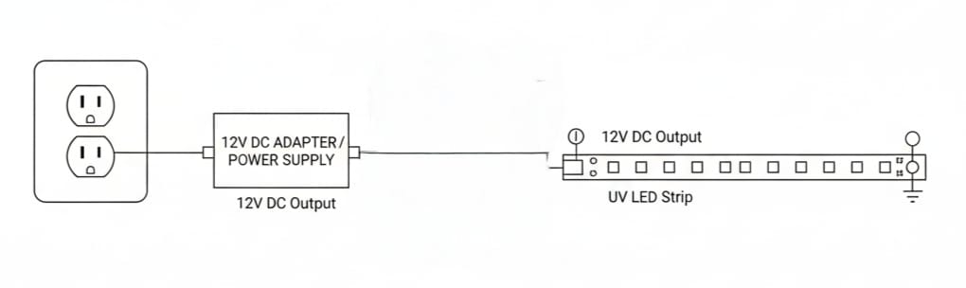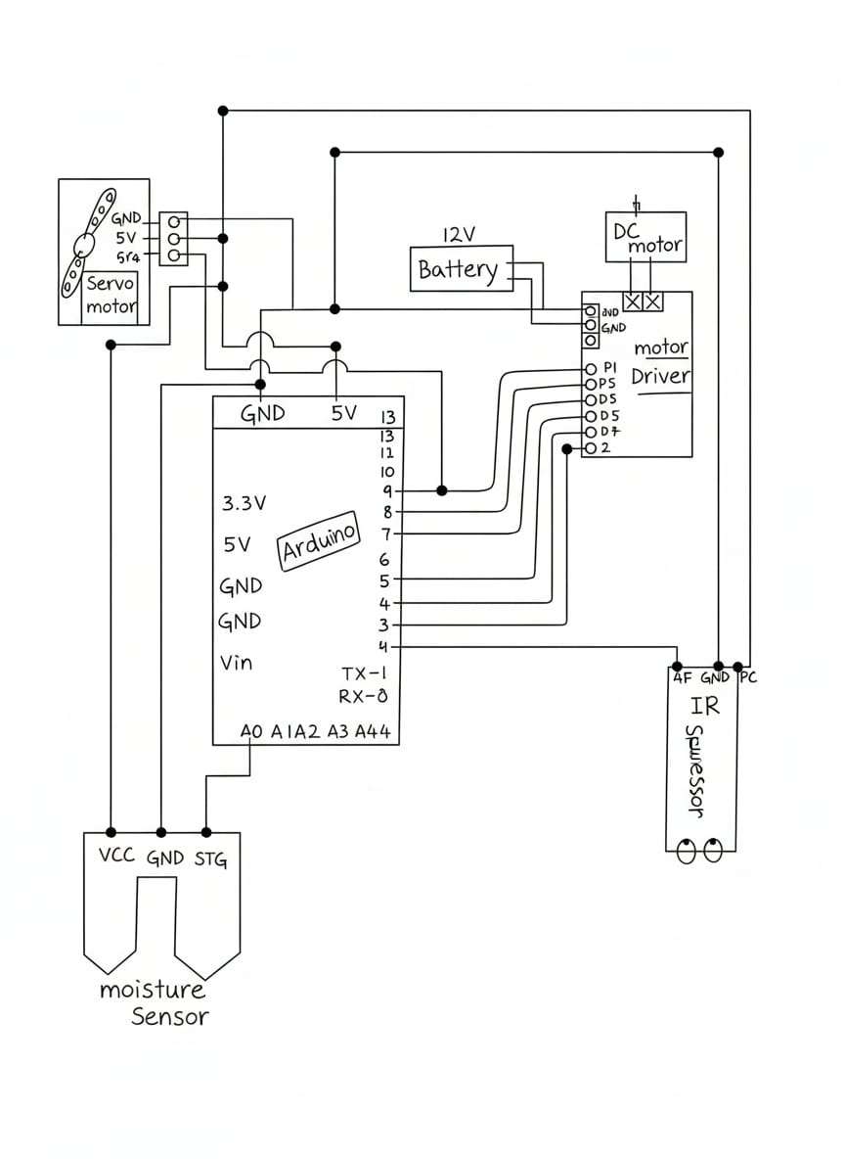

Fig. 2 Pin Diagram of proposed project
4.2.1 Flowchart

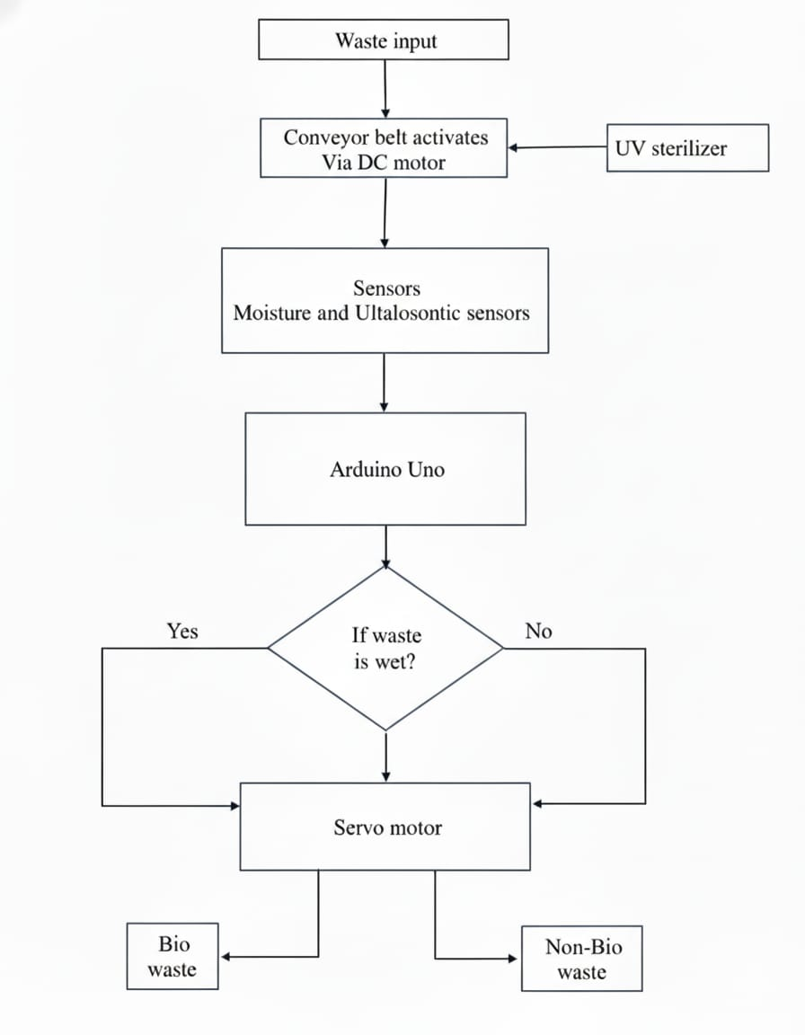

4.3 COMPONENTS USED IN THE PROJECT WORK:
- Arduino
- Conveyor Belt
- UV Lamp Sterilization
- Moisture Sensor
- Ultrasonic Sensor
- Servo Motor
- BO Motor and Jumper wires
- PWM Speed Controller
- DC Adaptor

4.3.1 Arduino:
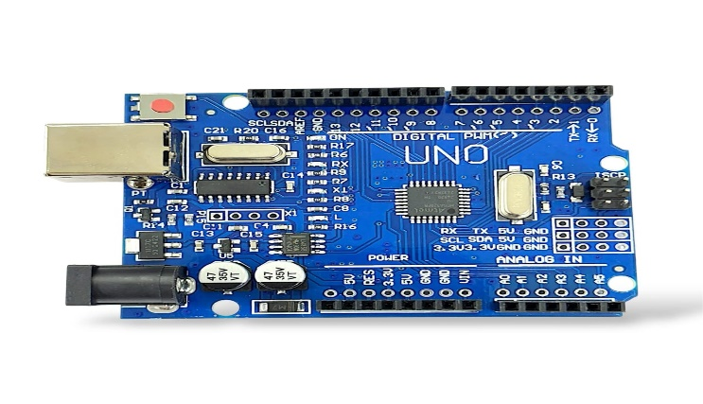
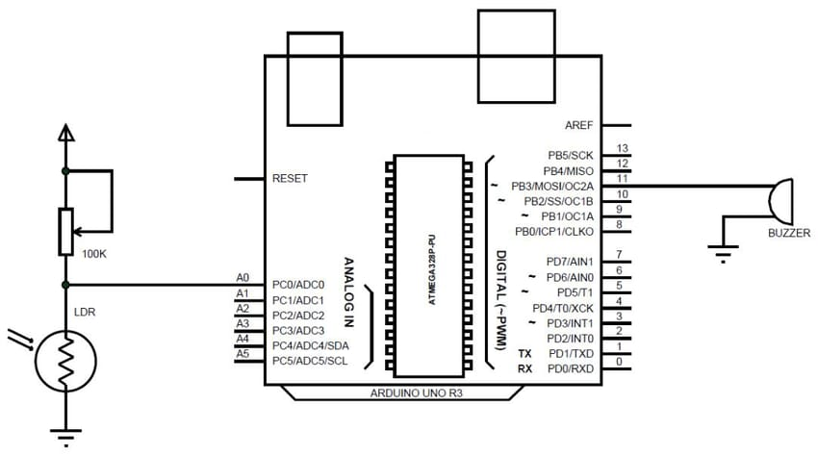
The Arduino Uno is a popular microcontroller board based on the ATmega328P chip. It operates at 5V and can be powered via USB or an external adapter. The board has 14 digital I/O pins and 6 analog input pins for connecting sensors and devices. Running at a 16 MHz clock speed with 32 KB of flash memory, it is programmed using the Arduino IDE with simple C/C++ code and is widely used for operate our project.
Specifications:
1. Microcontroller: ATmega328P running at 16 MHz
2. Operating Voltage: 5V (recommended input: 7–12V)
3. I/O Pins: 14 digital (6 PWM) and 6 analog inputs
4. Memory: 32 KB Flash, 2 KB SRAM, 1 KB EEPROM
5. Connectivity: Supports UART, I2C, and SPI communication

4.3.2 Conveyor belt:
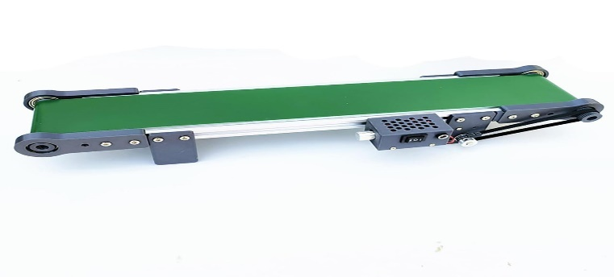

A conveyor belt is a mechanical system used to transport Waste materials or products from one place to another efficiently. It consists of a continuous belt made of rubber, fabric, or metal, which moves over rollers or pulleys powered by an electric motor. This can be used in horizontal for carry waste through further operation.

4.3.3 UV Light Sterilization:
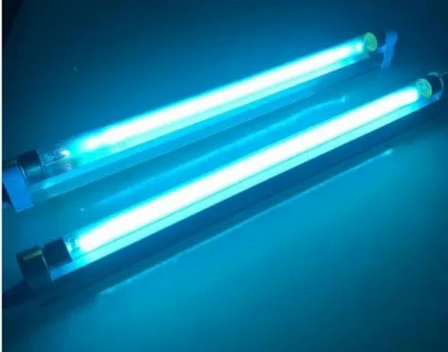

UV light sterilization is a method of killing or inactivating microorganisms such as bacteria, viruses, and fungi using ultraviolet (UV) light, particularly light (wavelength 200–280 nm). The UV rays damage the DNA or RNA of microbes, preventing them from reproducing and causing infections.
Specifications:
1. Wavelength Range: 100–400 nm
2. Types: UV-A (315–400 nm), UV-B (280–315 nm), UV-C (100–280 nm)
3. Most Effective for Sterilization: UV-C (around 254 nm)
4. Power Rating: 1 W – 30 W (varies by lamp or LED type)
5. Operating Voltage: 3–12 V (LED type) or 110–230 V (lamp type)

4.3.4 Moisture Sensor:
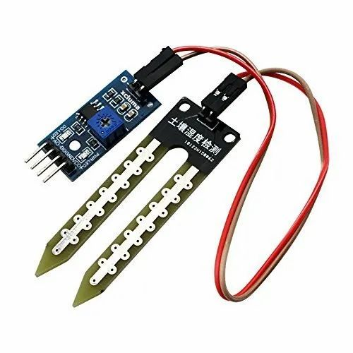
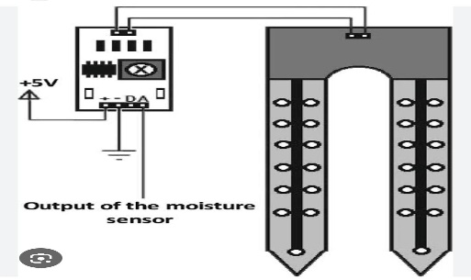
In biomedical waste segregation, a moisture sensor is used to identify the wetness level of waste, which helps in separating wet waste (like blood-soaked materials, bodily fluids) from dry waste (like plastics, glass, or packaging). This is important because wet waste requires special handling and treatment, such as autoclaving or chemical disinfection, while dry waste can be treated or recycled differently. Using moisture sensors improves safety, hygiene, and efficiency in managing biomedical waste in hospitals and laboratories.
Specifications:
1. Operating Voltage: 3.3V – 5V DC
2. Output Type: Both Analog and Digital
3. Current Consumption: Less than 20 mA
4. Sensing Range: Detects soil moisture from 0% (dry) to 100% (wet)
5. Interface: Analog output connected to Arduino analog pin (A0)
6. Applications: moisture monitoring, automatic irrigation systems, and plant watering projects.

4.3.5 Ultrasonic Sensor:
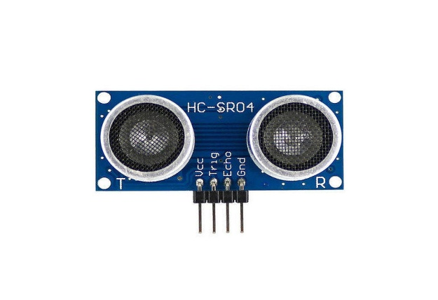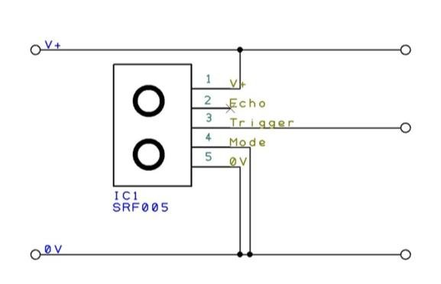
A PWM DC motor speed controller adjusts the motor’s speed by rapidly switching the supply voltage on and off. By varying the duty cycle, it changes the average power delivered to the motor, giving smooth and efficient speed control. Higher duty cycle results in higher speed, while lower duty cycle decreases the motor speed. This method provides precise control with minimal energy loss.
Specifications:
1.Input Voltage: 6–24V DC
2.Output Current: 5–30A
3.Control Method: PWM knob or external PWM signal
4.PWM Frequency: 1–20 kHz
6.Efficiency: >90%

4.3.6 Servo motor:
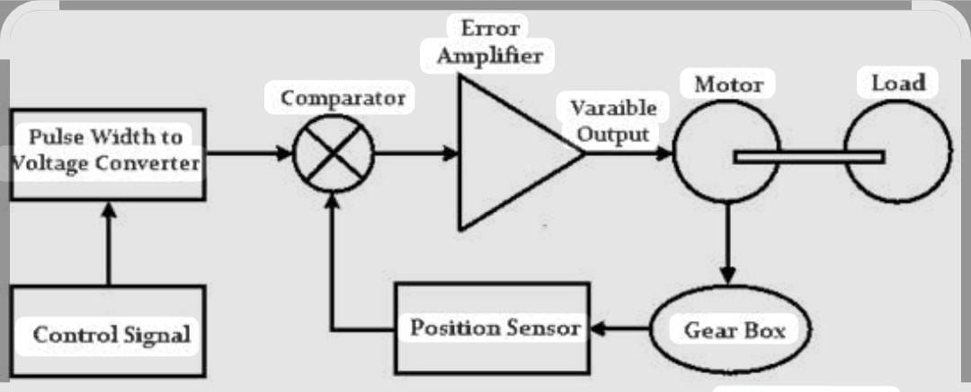
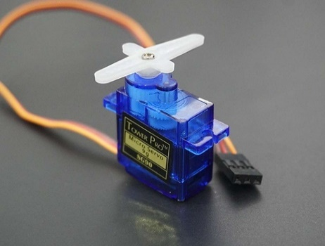

In a biomedical waste segregation project, a servo motor moves bins or flaps to automatically sort waste based on sensor signals, making the process safe and hygienic.
Specifications:
1.Operating Voltage: Typically 4.8V – 6V DC
2. Control Signal: PWM (Pulse Width Modulation)
3. Rotation Angle: Usually 0° to 180° (standard servo)
4. Torque: Around 2.5 kg.cm to 10 kg.cm (varies by model)
5. Speed: ~0.1 to 0.2 sec per 60° rotation

4.2.7 BO Motor and Jumper wires:
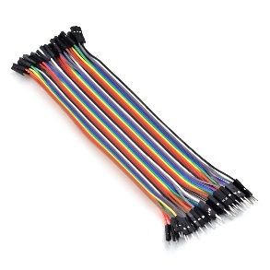
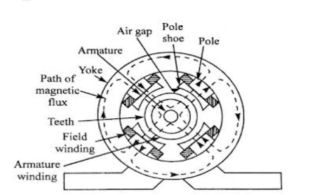
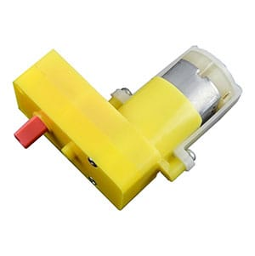
A BO motor moves conveyer belts to automate biomedical waste segregation, reducing manual handling. Jumper wires connect sensors and motors to the control board, enabling easy circuit setup.
Specifications:
1. Operating Voltage: Typically 3V – 12V DC
2. Speed: Around 1000 to 10,000 RPM (depends on motor type)
3. Current Rating: Usually 100 mA – 2 A
4. Torque: Varies from 0.1 to 5 kg.cm based on size and power
5. Direction Control: By reversing polarity of the supply

4.2.8 PWM Speed Controller:
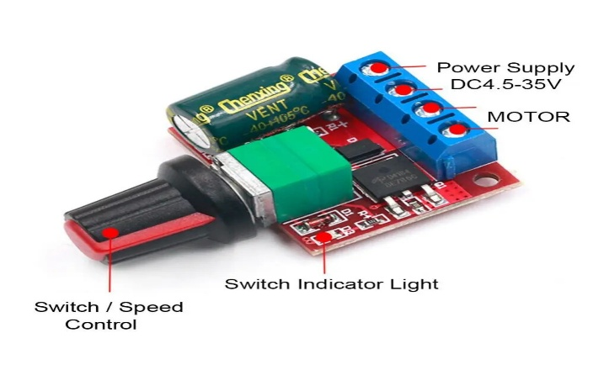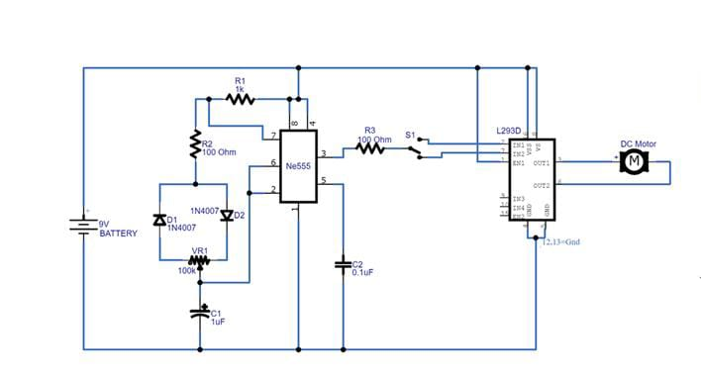
A PWM DC motor speed controller adjusts the motor’s speed by rapidly switching the supply voltage on and off. By varying the duty cycle, it changes the average power delivered to the motor, giving smooth and efficient speed control. Higher duty cycle results in higher speed, while lower duty cycle decreases the motor speed. This method provides precise control with minimal energy loss
Specifications:
1.Input Voltage: 6–24V DC
2.Output Current: 5–30A
3.Control Method: PWM knob or external PWM signal
4.PWM Frequency: 1–20 kHz
5.Efficiency: >90%

4.2.9 DC adapter
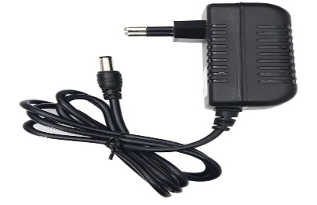

The 12V DC adapter is used to provide a stable and safe power supply to the UV sterilization unit in the biomedical waste segregation system. It converts 230V AC from the mains into 12V DC, which is suitable for operating the UV light.
Specifications:
1. Output Voltage: Commonly 5V, 9V, or 12V DC (depends on device)
2. Output Current: Typically 500 mA to 2 A
3. Input Voltage: 100V – 240V AC, 50/60 Hz
4. Polarity: Usually center positive (+) and outer negative (–)
5. Connector Type: Barrel jack (commonly 2.1 mm or 2.5 mm)

Specifications:
1.Input Voltage: 6–24V DC
2.Output Current: 5–30A
3.Control Method: PWM knob or external PWM signal
4.PWM Frequency: 1–20 kHz
5.Efficiency: >90%

4.2.9 DC adapter

The 12V DC adapter is used to provide a stable and safe power supply to the UV sterilization unit in the biomedical waste segregation system. It converts 230V AC from the mains into 12V DC, which is suitable for operating the UV light.
Specifications:
1. Output Voltage: Commonly 5V, 9V, or 12V DC (depends on device)
2. Output Current: Typically 500 mA to 2 A
3. Input Voltage: 100V – 240V AC, 50/60 Hz
4. Polarity: Usually center positive (+) and outer negative (–)
5. Connector Type: Barrel jack (commonly 2.1 mm or 2.5 mm)

CHAPTER 5

RESULTS AND DISCUSSION
5.1 RESULTS
The Automated Biomedical Waste Management System using Arduino and UV Sterilization was successfully developed and tested. The system was able to:
1. Used conveyor belt to move waste.
2. Go through sterilize the waste using UV light before segregation.
3. Identify the waste type using moisture and ultrasonic sensors.
4. Automatically segregate the waste into biodegradable and non-biodegradable bins using servo-controlled mechanisms.
5. Reduce manual handling of biomedical waste, improving safety and hygiene.

5.2 ANALYSIS
The performance of each module in the system was evaluated:

1. Sensor Analysis
- Moisture Sensor: Successfully differentiated between wet (biodegradable) waste like blood-soaked cotton and dry waste like plastic gloves. Output response was stable and suitable for Arduino analog reading.
- Ultrasonic Sensor: Effectively detected non-biodegradable materials such as bottles, plastic syringes, and rubber items.
- UV Sterilizer: Provided effective surface-level sterilization, reducing microbial contamination before waste handling. UV-C at 254 nm is known to inactivate most bacteria and viruses.

2. Mechanical System Analysis
- Conveyor Belt + DC Motor: Maintained smooth movement of waste toward the detection zone.
- PWM controller provided stable speed control.
- Servo Motor: Accurately directed waste into appropriate bins based on sensor output.

3. Arduino Processing
- Arduino UNO efficiently processed sensor data with minimal delay.
- Classified waste based on conditional logic and controlled actuators accordingly.

4. System Efficiency
- Reduced the need for human contact.
- Waste segregation accuracy improved compared to manual methods.
- UV sterilization added an extra layer of safety.

5.3 DISCUSSIONS

The project provides a safe and automatic method for handling biomedical waste. The system uses sensors and UV light to first disinfect the waste and then separate it into the correct bins. This reduces human contact with harmful and infectious materials. The Arduino processes the sensor signals and controls the conveyor belt and servo motor to direct the waste properly.

The system worked effectively during testing, showing accurate segregation and smooth operation. Although UV light only sterilizes the surface of the waste and sensors may sometimes misread mixed items, the overall system improves hygiene, safety, and efficiency in hospitals and labs. This shows that automation can greatly help in biomedical waste management.

CHAPTER 6

ADVANTAGES, LIMITATIONS, APPLICATIONS AND CONCLUSION

6.1 ADVANTAGES

1. Safer for hospital workers – Waste is handled automatically, reducing the chance of touching infected materials.
2. Hygienic waste management – UV light kills germs before the waste is separated.
3. Reduces human errors – Sensors help in proper and accurate segregation.
4. Eco-friendly system – No chemicals are used for sterilization.
5. Low-cost and easy to use – Uses simple components like Arduino, sensors, and motors.
6. Faster waste processing – Automation makes the segregation process quicker.

6.2 LIMITATIONS

1. UV light cleans only the surface – It cannot sterilize waste that is thick or stacked in layers.
2. Some germs may survive – UV light may not kill very strong or deep-layered microorganisms.
3. Sensor confusion – Very mixed or unusual waste items may not be detected correctly.
4. Power dependency – The system requires continuous power to run the conveyor, UV lamp, and sensors.
5. Limited waste categories – It mainly separates into bio and non-bio; more categories need additional sensors.

6.3 APPLICATIONS

1. Hospitals – For clean and safe segregation of biomedical waste from patients, wards, and labs.
2. Clinics and Diagnostic Centers – Helps small facilities manage waste properly.
3. Laboratories – Keeps the lab environment safe by disinfecting and sorting waste.
4. Pharmacy and research labs – For disposing of contaminated materials safely.
5. Waste storage rooms – UV sterilization helps reduce infections in waste collection areas.

6.4 CONCLUSIONS:

The project “Automated Biomedical Waste Management using Arduino and UV Sterilization” was successfully designed and tested. It helps in automatically separating and disinfecting biomedical waste without the need for human contact.

By using sensors, Arduino, and UV light, the system can identify the type of waste and place it in the correct bin while also killing harmful germs on its surface. This makes waste handling safer, faster, and more hygienic compared to manual methods.

The system is low-cost, easy to use, and environmentally friendly, which makes it suitable for hospitals, clinics, and laboratories.

Overall, the project shows that automation and UV technology can play a big role in improving waste management and protecting healthcare workers from infections.

COST ESTIMATION

Materials | Cost in Rupees
Arduino Uno | ₹ 450
Ultrasonic Sensor | ₹ 150
PWM Speed Controller | ₹ 175
Moisture Sensor | ₹ 350
DC motor | ₹ 200
UV Sterilization Lamp | ₹ 500
Breadboard (Medium Size) | ₹ 100
Jumper Wires (Pack of 40) & Conveyor Belt | ₹ 230
External 5V Power Adapter/Cable | ₹ 150
Servo motor | ₹ 250
Total | 2500

REFERENCES

[1] P.Gnanapriya, S. Harinipriya, P. Dharshini, M. Pothieswarar, and S.Pranesh,“Portable Healthcare Waste Disinfector and Disposer,” Proc. 3rd International Conference … , 2025. doi:10.1109/IDCIOT64235.2025.10915142

[2] S. Wardoyo, D. Adam, T. Anwar, and J. J. Pramudiatia, “Effectiveness of a Ultraviolet-Equipped Waste Box in Reducing Bacterial Contamination in Laboratory Waste,” BMC Research Notes, vol. 18, no. 1, Article (2025). doi:10.1186/s13104-025- 07375-0.

[3] Y.-S. Park, M.-J. Kim, Y.-S. Yoon, T.-W. Jeon, and H.-H. Choi, “A Study of the Effect of Testing for Diversification of Healthcare Waste Sterilization and Crushing Facilities,” Heliyon, vol. 10, no. 11, e31962, 2024. doi:10.1016/j.heliyon.2024.e31962.

[4] A. Roselin C., M. Arun Prasath, C. Rumesh Krishna, and A. Mohanarathinam, “Clinical Waste Storage System with Contamination Prevention Mechanism using UV and Arduino Microcontroller,” in Proc. 2023 International Conference on Inventive Computation Technologies (ICICT 2023), pp. 1585–1591, 2023. doi:10.1109/icict57646.2023.10134053.

[5] A. Azmin, S. Ak (Sherilyn Ak), A. Zanal, et al., “Ultraviolet Disinfection for Bio-Contaminated Surfaces with Image-Based Navigation,” (paper / chapter; UV sanitization robot; low-cost prototype)

[6] C. Ciugudeanu, D. Beu, and M. Buzdugan, “SteriLightVent: Hybrid UV-C Decontamination System for Air and Surface Sterilization,” (conference paper — SteriLightVent), Proc. Int. Conf. on Applied & Theoretical Electricity (or related conference), May 2021.

[7] V. Manda (Mandra), S. Balachandran, D. Mahesh, R. Houji, et al., “UV Sterilizing Dustbin,” International Journal for Modern Trends in Science and Technology, vol. 7, no. 11, pp. 71–75, Nov. 2021. doi:10.46501/IJMTST0711013.

[8] A. Mohtasebi, R. Abedi Sarvestani, H. Dabiri, M. Sadani, N. Alavi, M. Abtahi, and R. Alimi, “Effective Methods for the Decontamination of Healthcare Waste: Ozone and UV-C Radiation Process,” J. Air & Waste Management Assoc. (or Journal of Environmental/ Air & Waste Manag. Assoc.), 2024 — study reporting ozone + UV-C effectiveness.

[9] M. A. Aboamer, D. H. Elgohary, A. A. Almukil, A. A. Aboamer, I. M. Alarifi, M. Bakouri, and N. A. R. Mohamed, “A Comparative Study of Mechanical Behavior of ABS Material Based on UVC Sterilization for Medical Usage,” Journal of Mechanical Science and Technology, vol. 36, pp. 3373–3385, 2022. doi:10.1007/s12206-022-0616-6.

[10] H. Runcie, “Sort Your Waste! An Audit on the Use of Clinical Waste Bins and Its Implications,” Future Healthcare Journal, vol. 5, no. 3, pp. 203–206, Oct. 2018. doi:10.7861/futurehosp.5-3-20

[11] P. Raundale, P. Singh, and A. Patil, “IoT-Based Biomedical Waste Classification, Quantification and Management,” International Journal of Innovative Science and Research Technology (IJISRT), vol. 7, no. 6, pp. 1582–1586, 2022.

[12] I. P. D. Yudha, I. M. A. Gunawan, and I. N. S. Rai, “Developing Sustainable Solid Medical Waste Management Based on ERP,” International Journal of Sustainable Engineering and Technology, vol. 5, no. 3, pp. 45–52, 2023.

[13] Inayatulloh and F. Evan, “Optimizing Waste Management Operational Performance through Blockchain,” International Journal of Advanced Computer Science and Applications (IJACSA), vol. 12, no. 10, pp. 631–637, 2021.

[14] Y. Vaziri and A. H. Sodhro, “Energy-Aware Smart Routing for Biomedical Waste Management,” IEEE Access, vol. 10, pp. 78544–78552, 2022.

APPENDIX-1

Program Code / Source Code

#include <Servo.h>

#define moistPin 8 // Moisture sensor digital pin (DO)
#define trig 3 // Ultrasonic trigger pin
#define echo 4 // Ultrasonic echo pin

Servo myServo;

void setup() {
Serial.begin(9600);

pinMode(moistPin, INPUT);
pinMode(trig, OUTPUT);
pinMode(echo, INPUT);

myServo.attach(10); // Servo signal wire connected to pin 10
myServo.write(90); // Start at base position (90°)
delay(3000);
}

void loop() {
// --- Ultrasonic sensor reading ---
long duration, distance;
digitalWrite(trig, LOW);
delayMicroseconds(2);
digitalWrite(trig, HIGH);
delayMicroseconds(10);
digitalWrite(trig, LOW);

duration = pulseIn(echo, HIGH);
distance = duration * 0.034 / 2; // Convert to cm

Serial.print("Distance: ");
Serial.print(distance);
Serial.println(" cm");

// --- Gatekeeper logic ---
if (distance > 0 && distance <= 20) {
Serial.println("Object Detected");

int moistValue = digitalRead(moistPin);
Serial.print("Moisture Digital Value: ");
Serial.println(moistValue);

if (moistValue == HIGH) {
// Soil is dry → move 90° → 150° and back
Serial.println("Soil is Dry");
for (int angle = 90; angle <= 150; angle++) {
myServo.write(angle);
delay(15);
}
for (int angle = 150; angle >= 90; angle--) {
myServo.write(angle);
delay(15);
}
} else {
// Soil is wet → move 90° → 30° and back
Serial.println("Soil is Wet°");
for (int angle = 90; angle >= 30; angle--) {
myServo.write(angle);
delay(15);
}
for (int angle = 30; angle <= 90; angle++) {
myServo.write(angle);
delay(15);
}
}
} else {
// No object → moisture sensor ignored, servo stays at base
Serial.println("No Object");
myServo.write(90);
}

delay(2000);
}

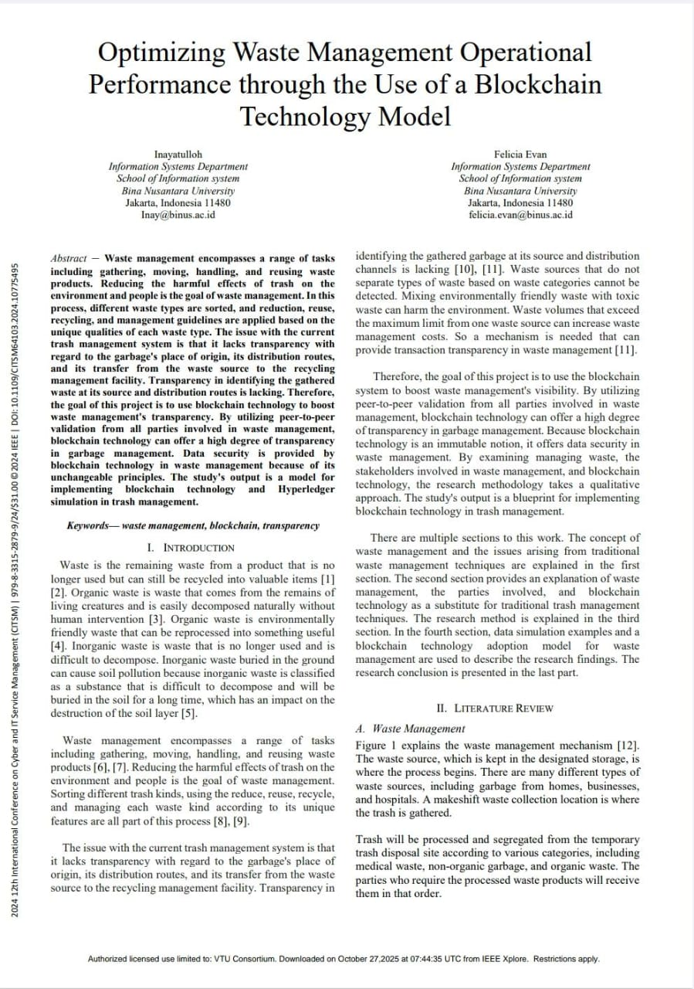

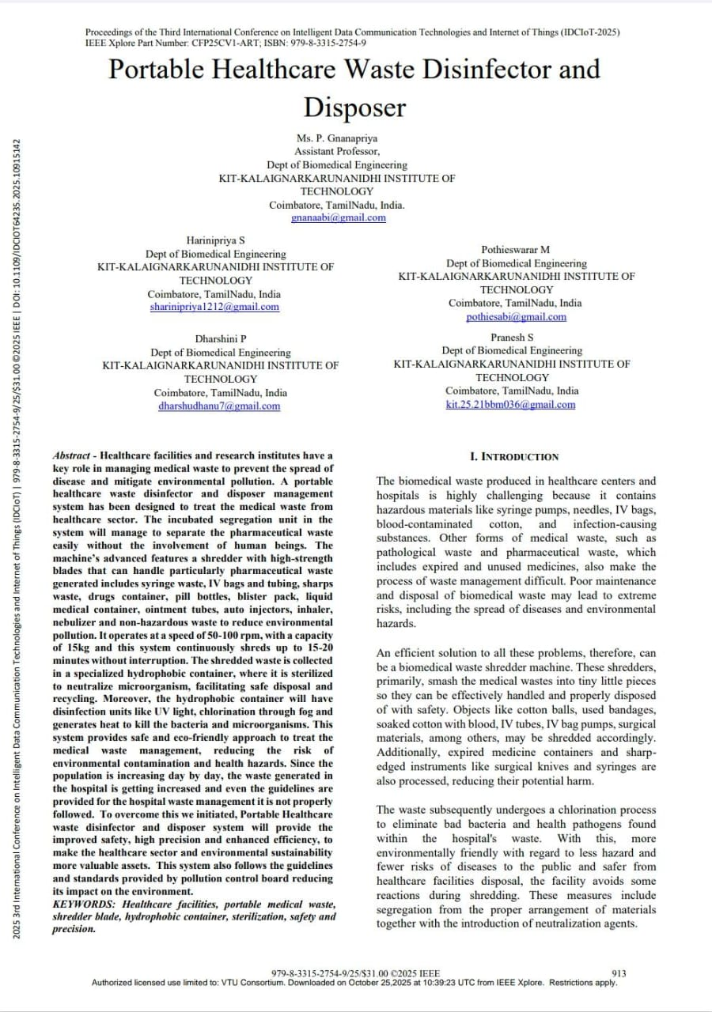

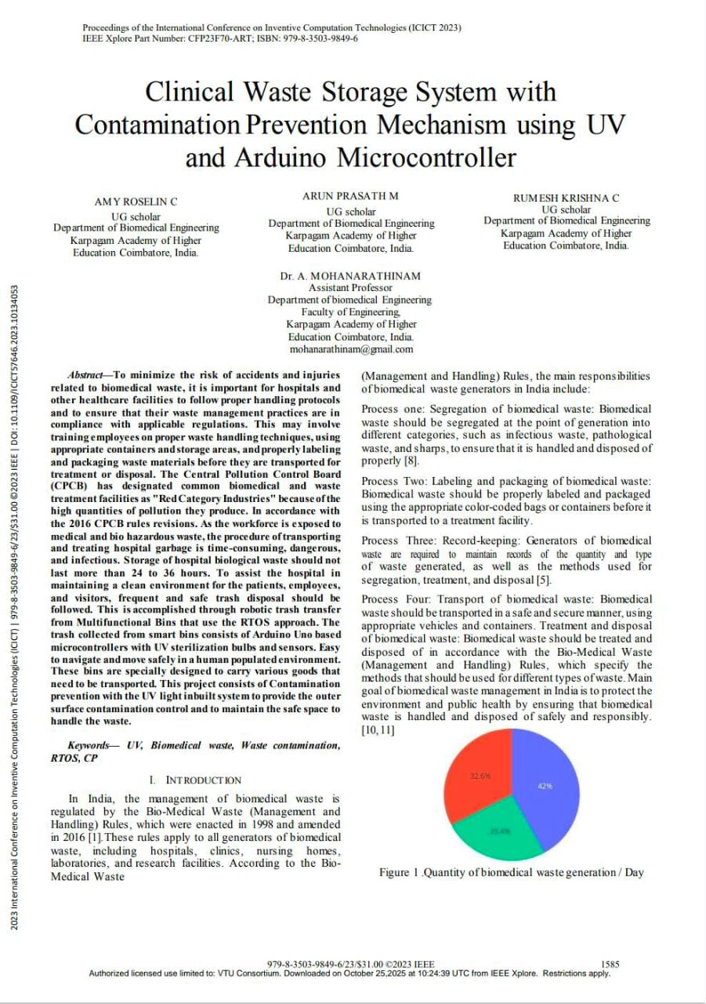

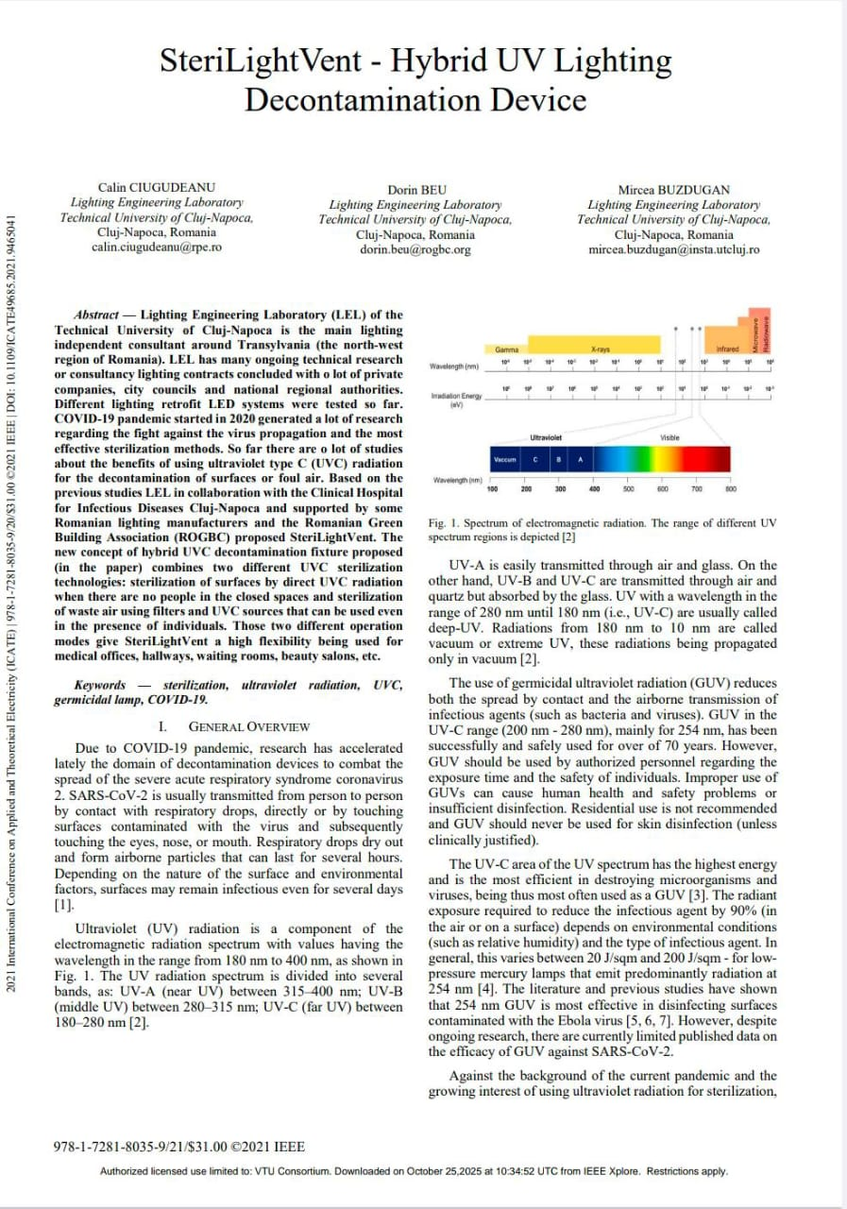

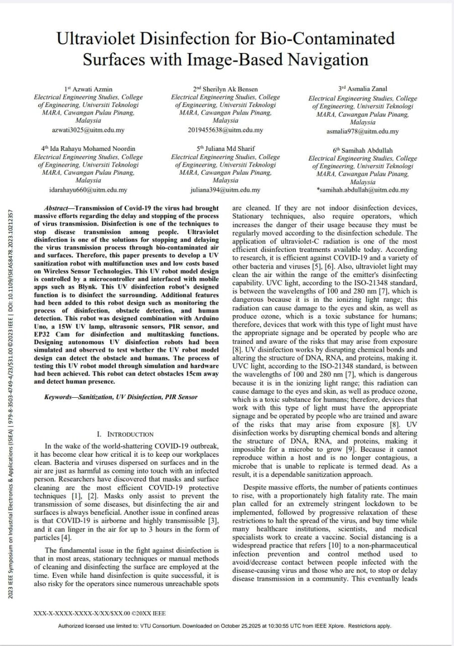

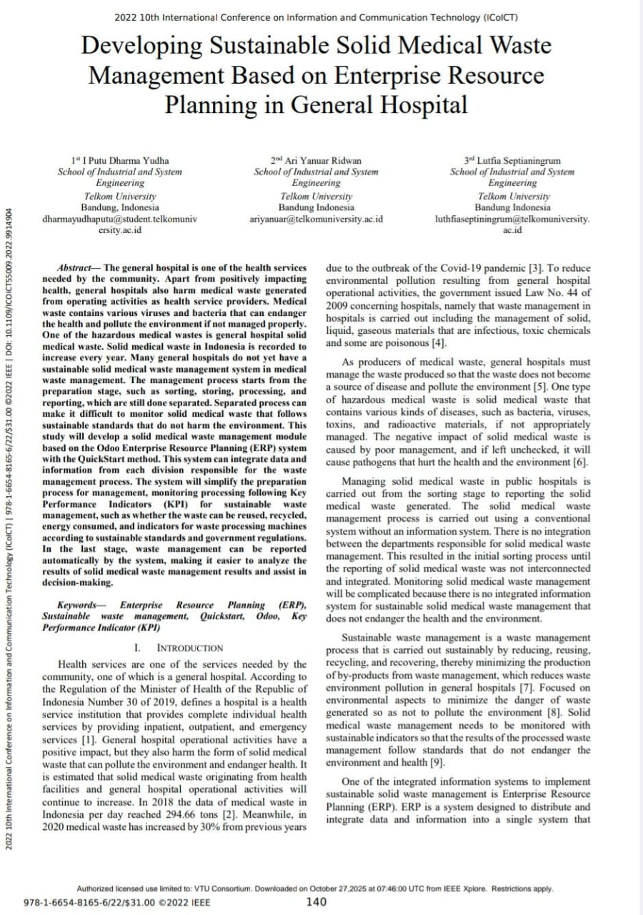

PROJECT BATCH STUDENTS DETAILS
1 | Name of the Student | : Vinay CS | 
1 | USN | 4UB23EI059
1 | Date of Birth | 4/9/2005
1 | Permanent Address | Nittuvalli, Davangere
1 | Official Mobile Number | 9902384452
1 | Official E-mail ID
2 | Name of the Student | : Vivekanand RK | 
2 | USN | 4UB23EI060
2 | Date of Birth | 17/02/2005
2 | Permanent Address | Bankapur, Haveri
2 | Official Mobile Number | 7676496658
2 | Official E-mail ID
3 | Name of the Student | : Y U Sneha | 
3 | USN | 4UB23EI061
3 | Date of Birth | 24/10/2005
3 | Permanent Address | Horakere, Jagalur
3 | Official Mobile Number | 9739695808
3 | Official E-mail ID
4 | Name of the Student | : Bhavana TS | 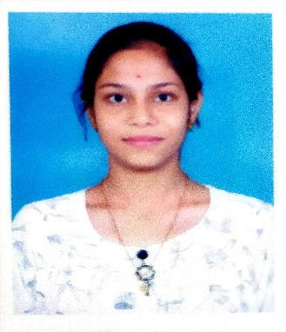
4 | USN | 4UB23EI062
4 | Date of Birth | 9/01/2005
4 | Permanent Address | Nittuvalli, Davangere
4 | Official Mobile Number | 7019180992
4 | Official E-mail ID

